Football Database

This database is designed to summary a football game, including the lineup of the football club used in game, and the events happened in game.

The country table stores information about the country that the game is played in. this information is necessary for the rules of the specific championship in that country.

The competition table stores information about the competition (championship such as Premier League, UEFA Champions League), also the date of the match, and the teams that take part in match.

The team table stores information about the team name.

The player table stores information about each player that is in a team as well as their number that they have in game.

The lineup table stores information about each player that take part in the game from the competition match, as well as their position in game.

The last but not least, the most important one, that is based on all above, the event table, stores all data about all events happening during the game, such as faults, yellow card, red card and goals and the minute it happens.

Overall, this football match database is important to summary a game of football, with all the important data.

Starting with, I created the tables with only the primary key

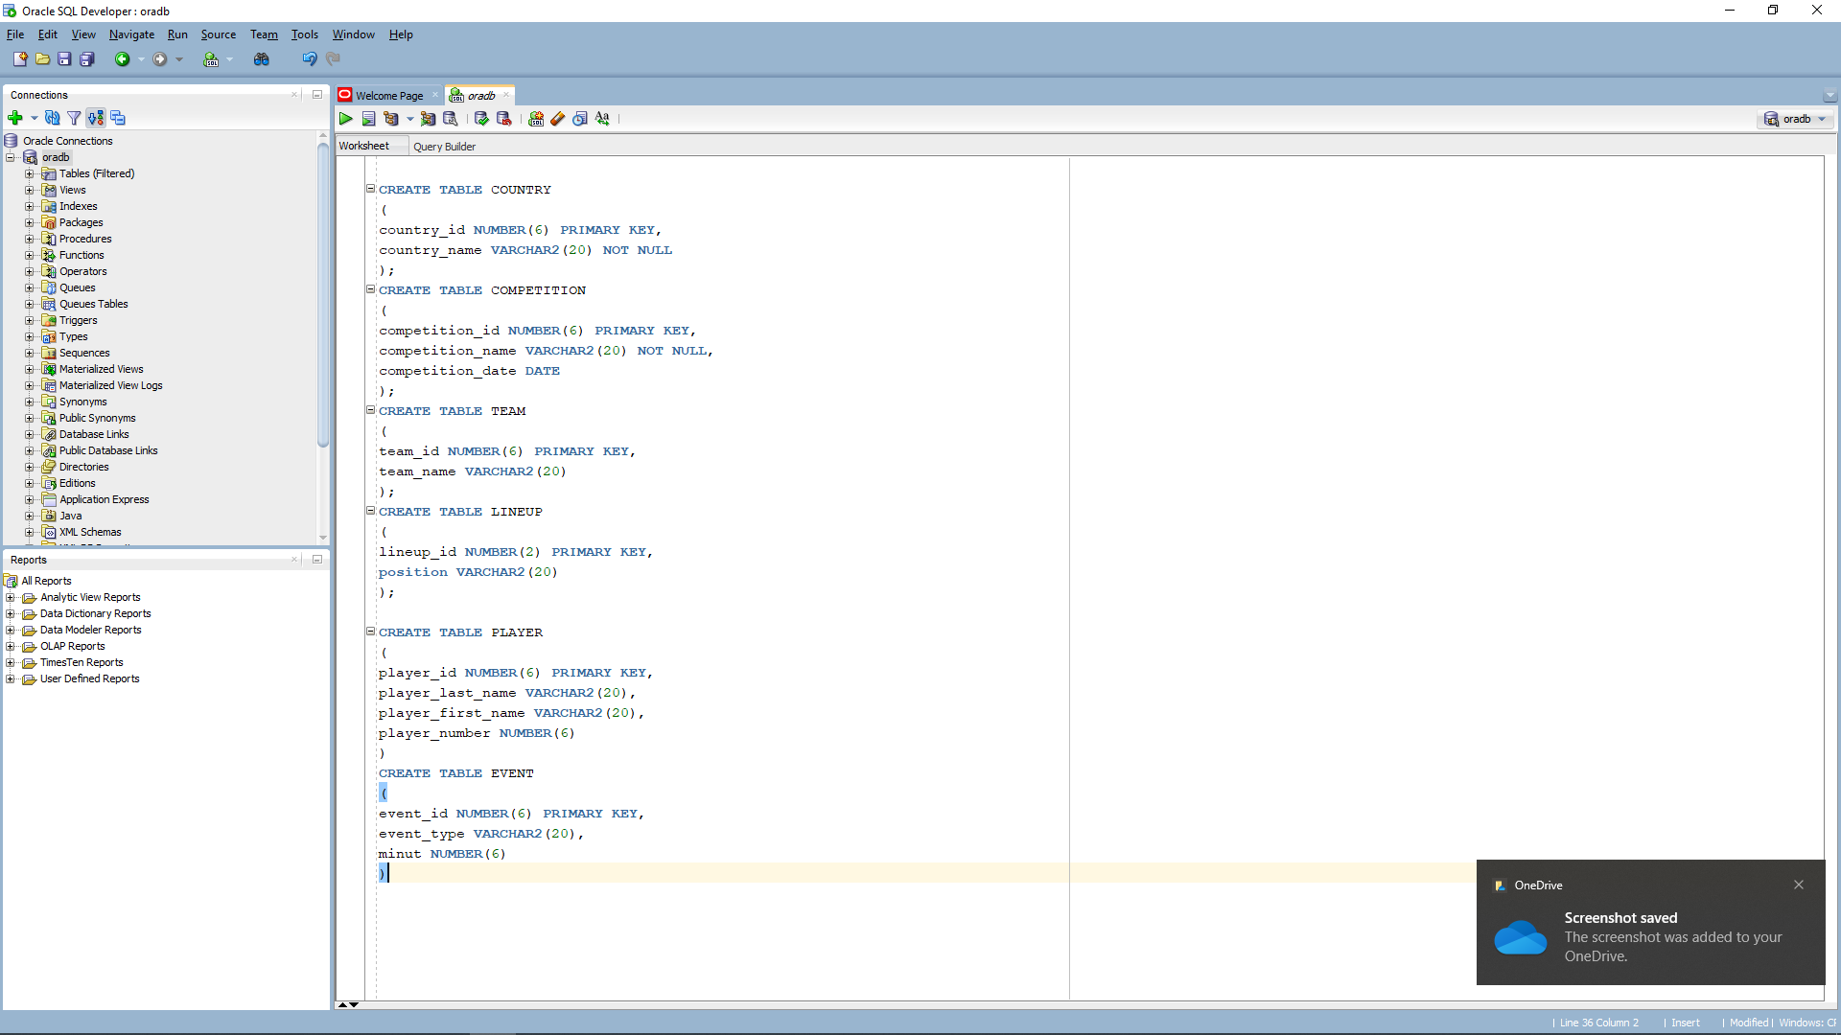

After that, I introduced all foreign keys for each table, using alter table:

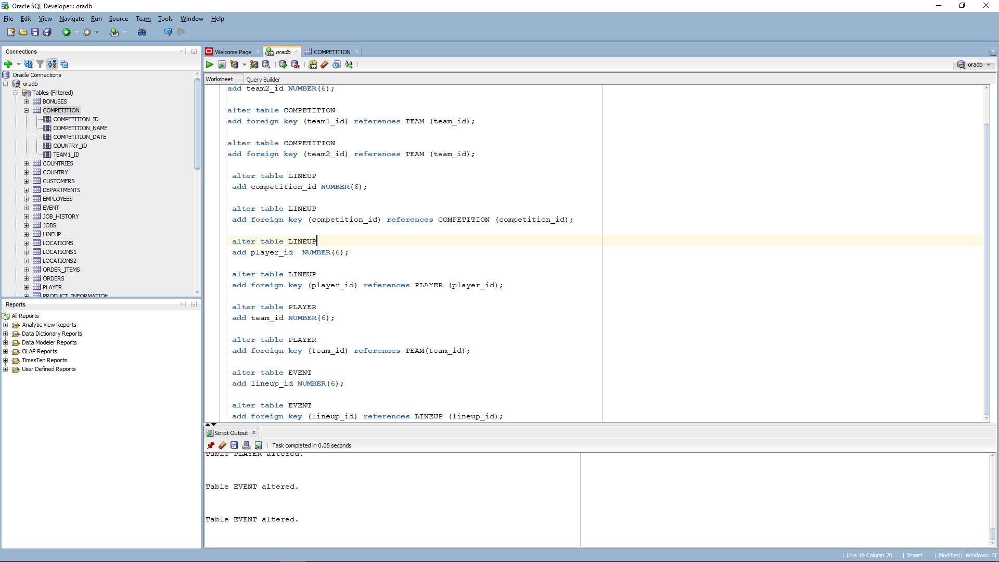

This is the schema of my database: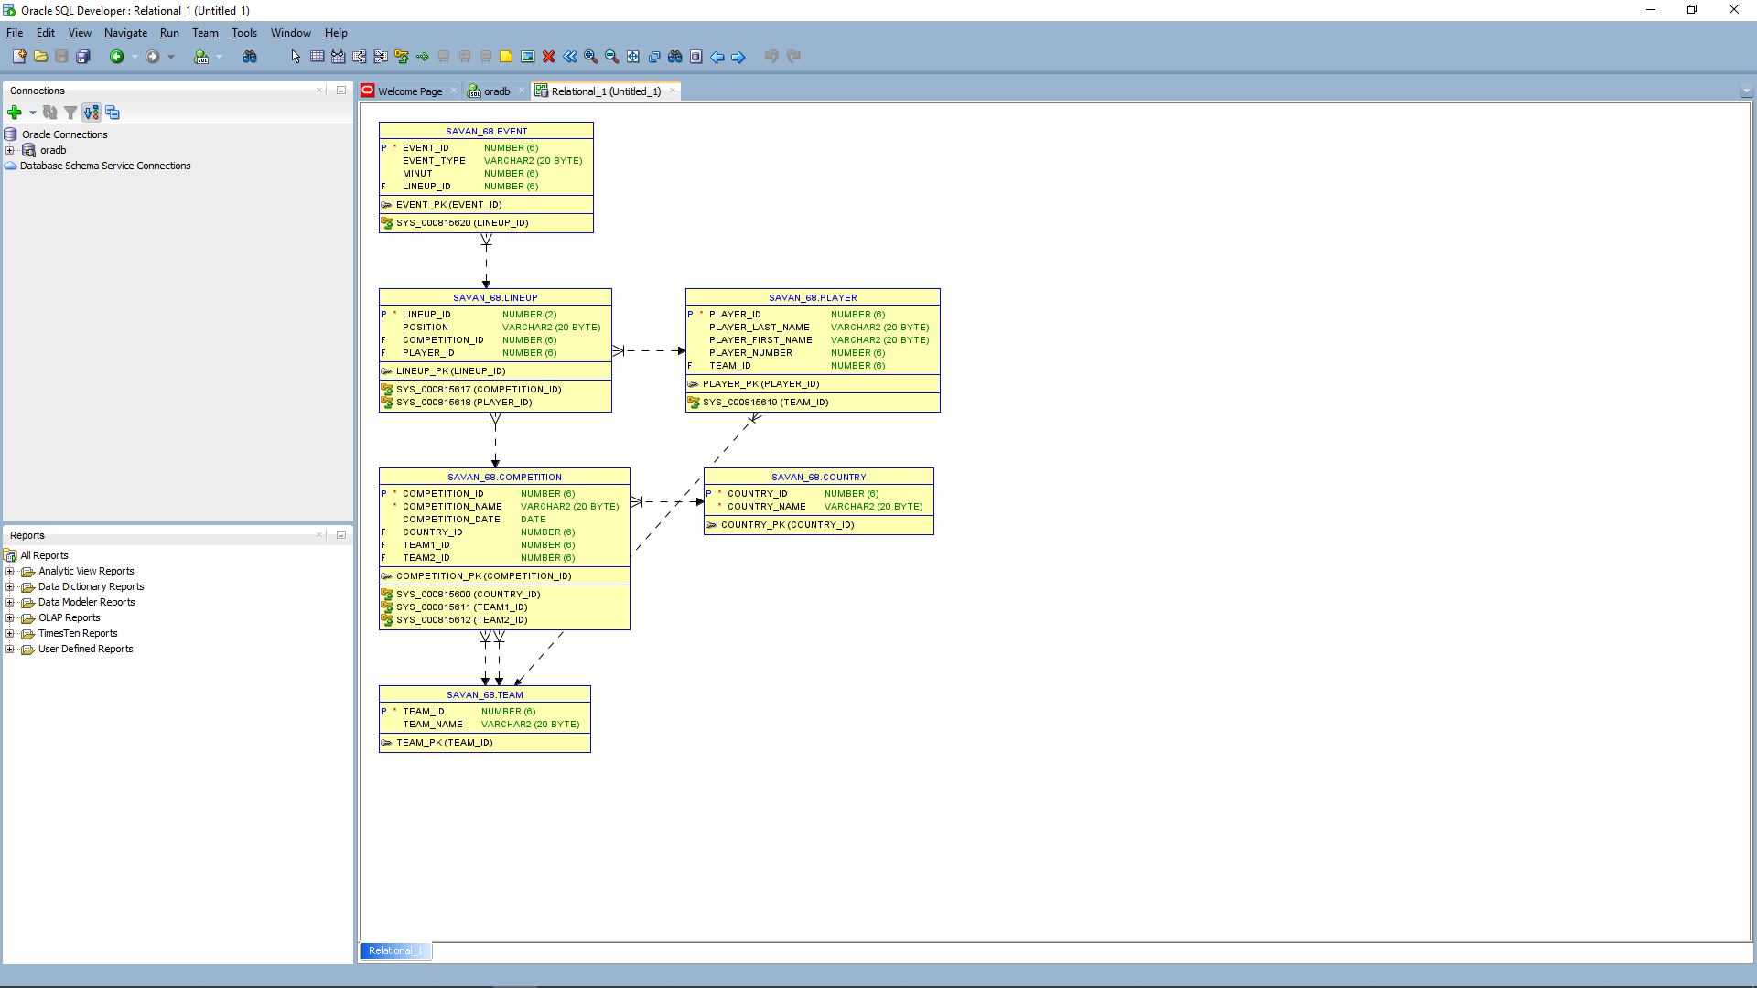

Furthermore, I had to introduce data in each table using insert function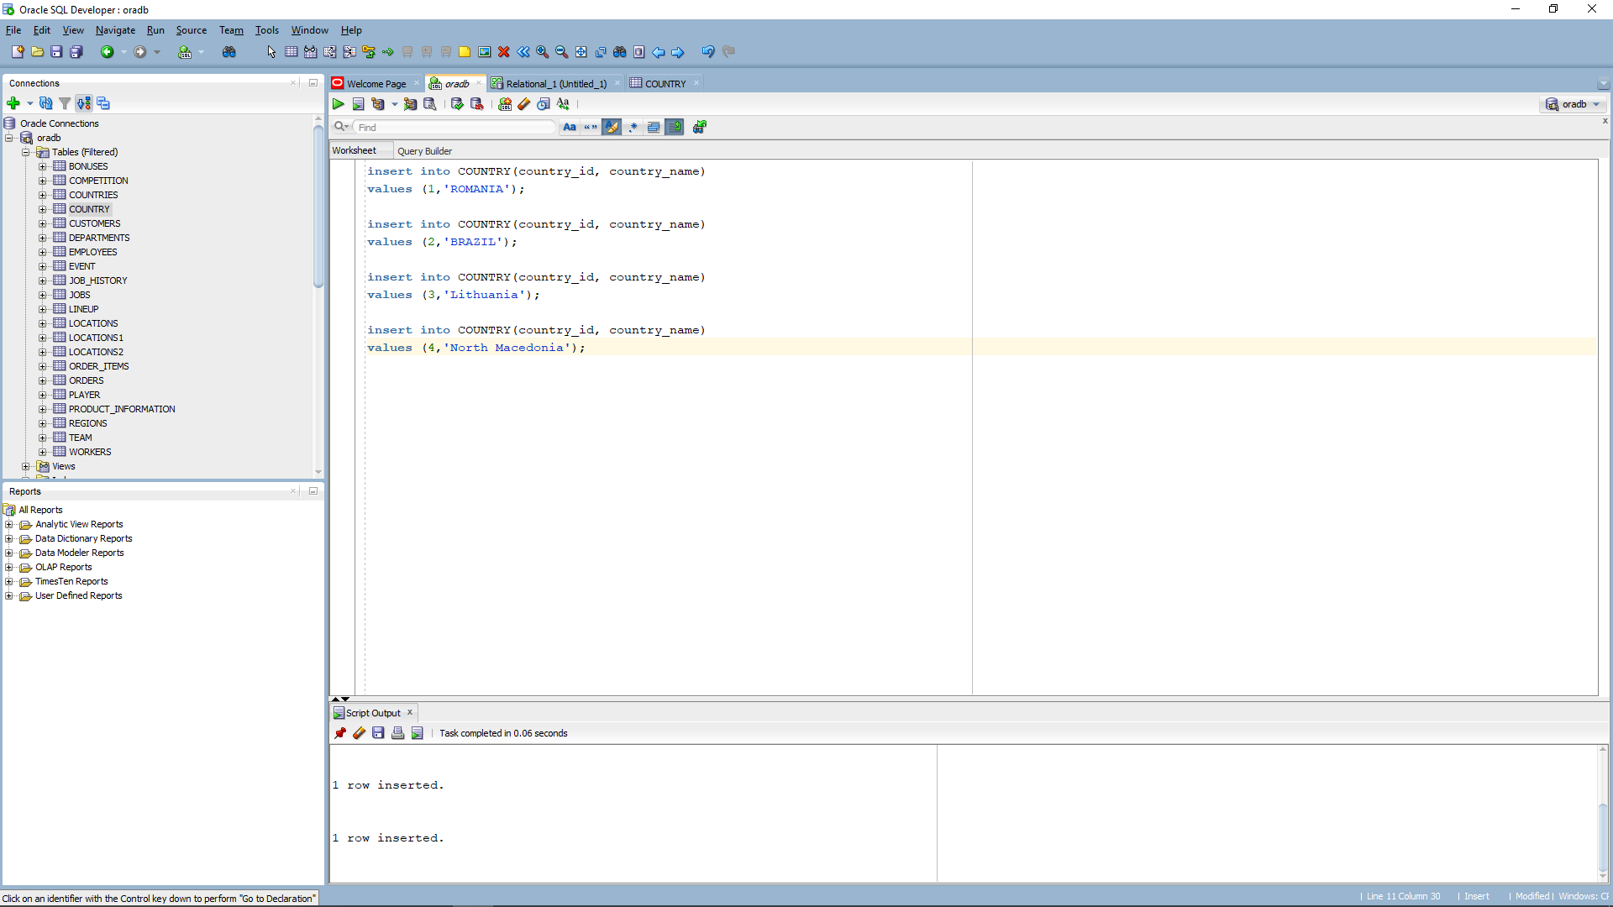

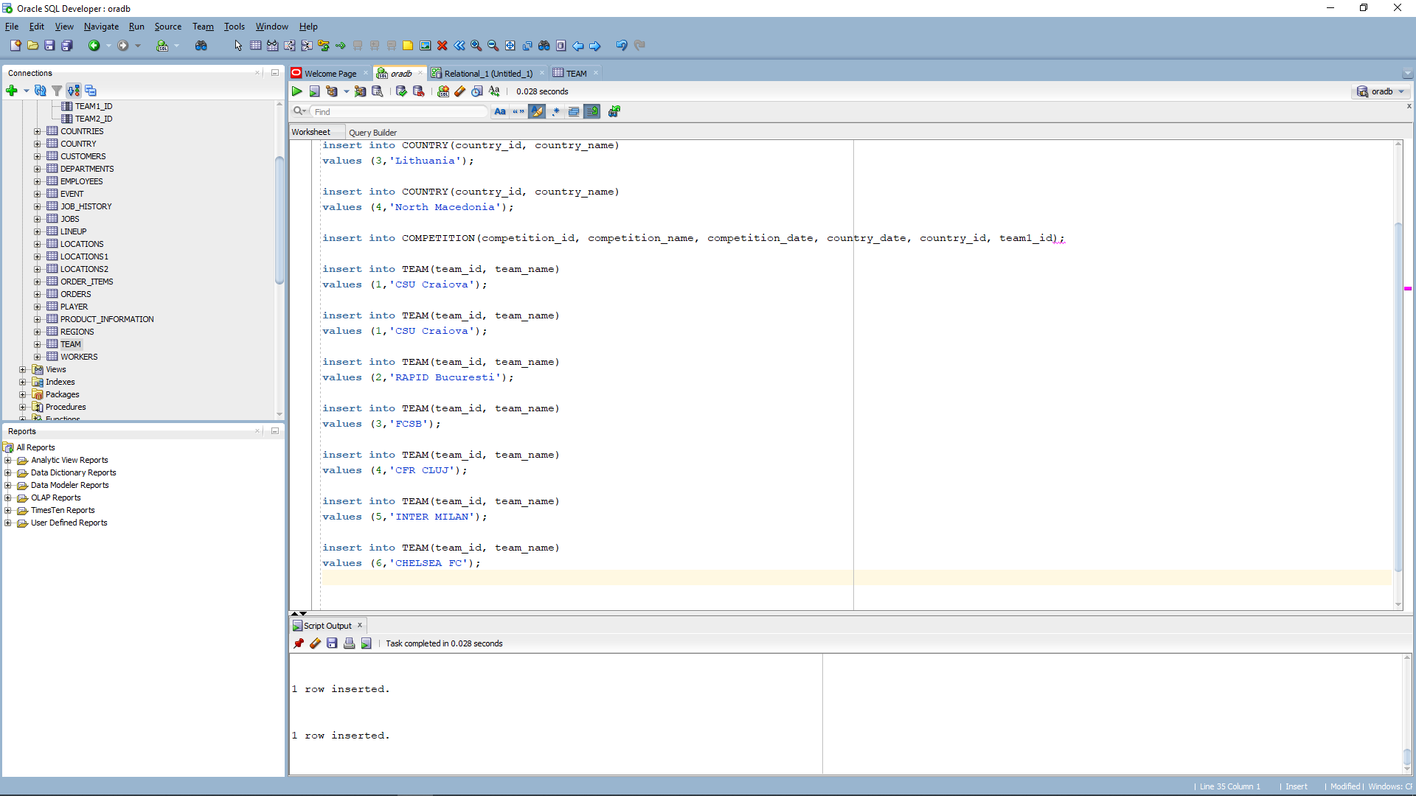

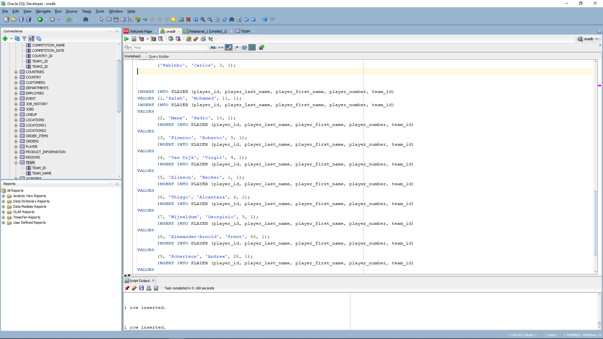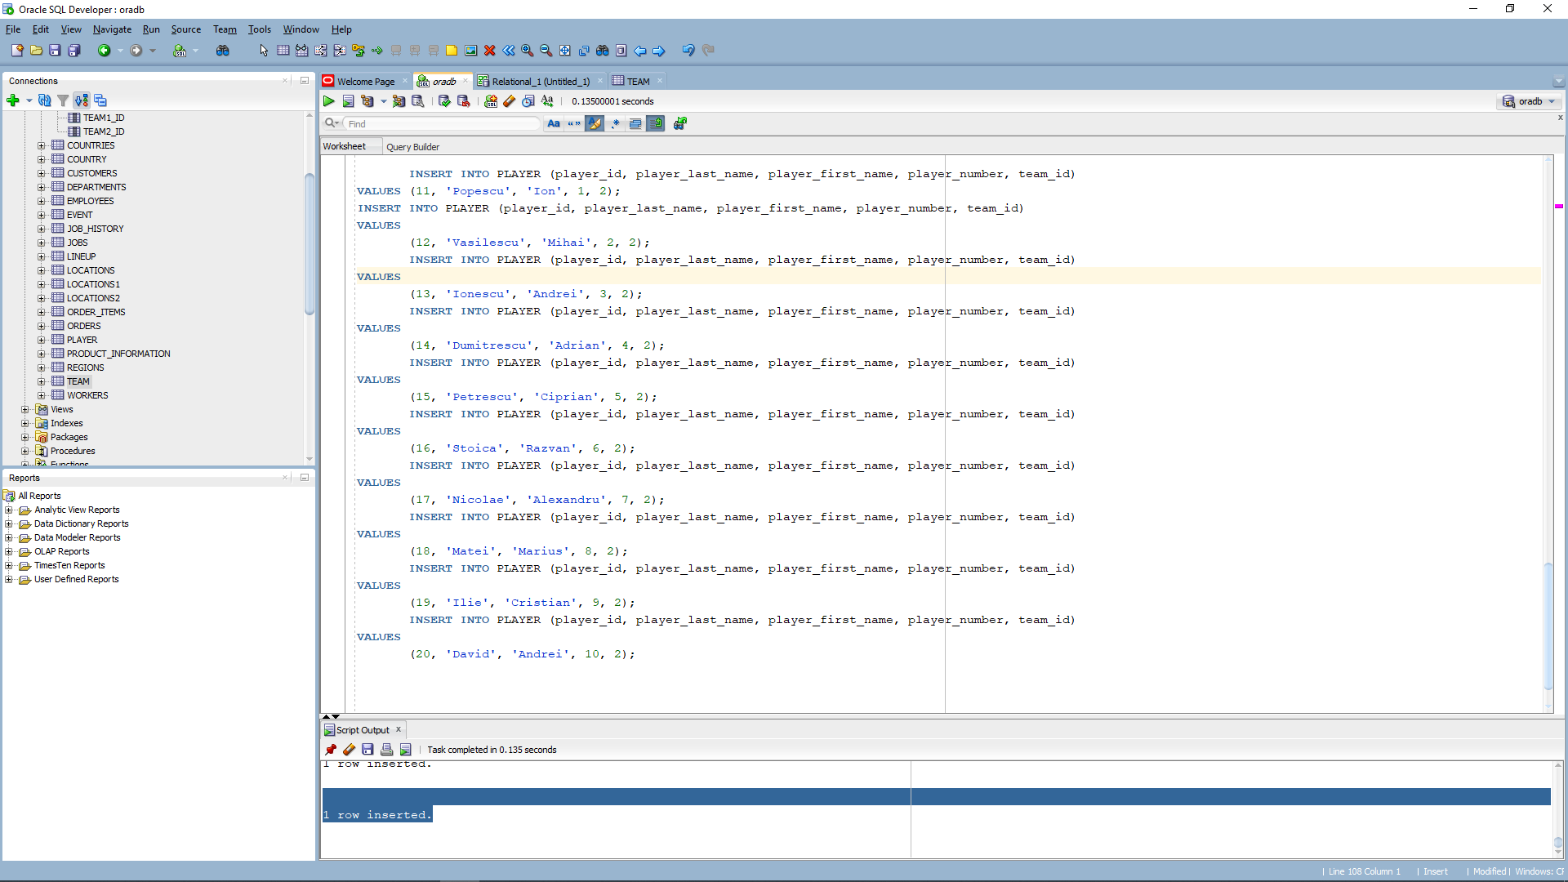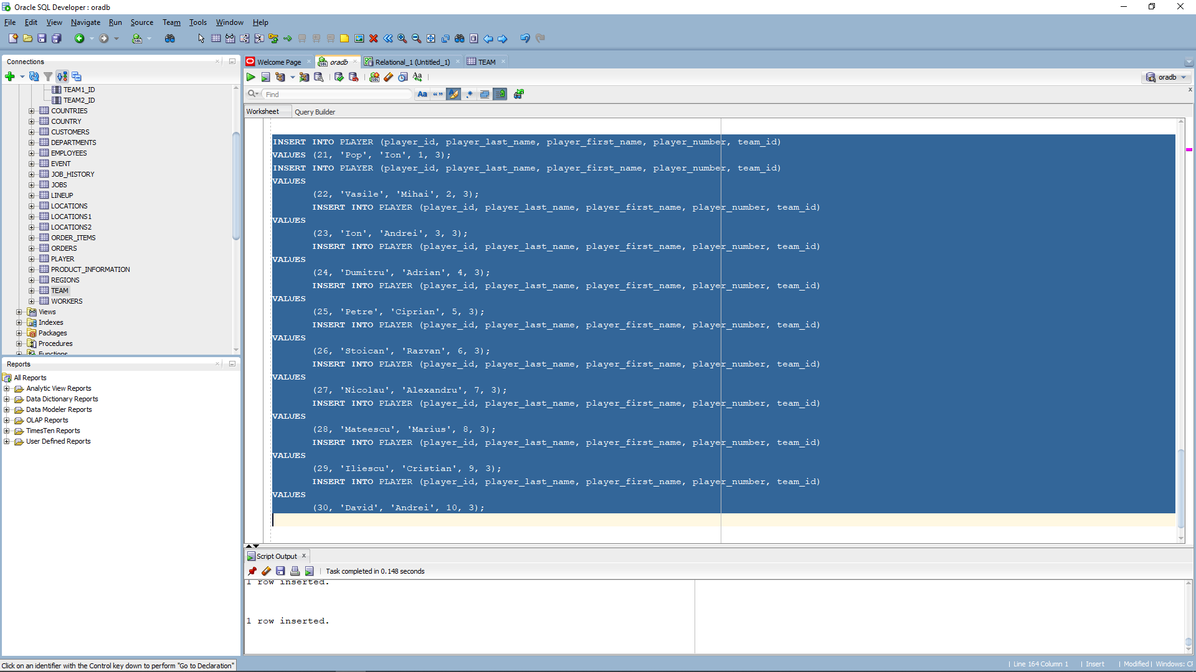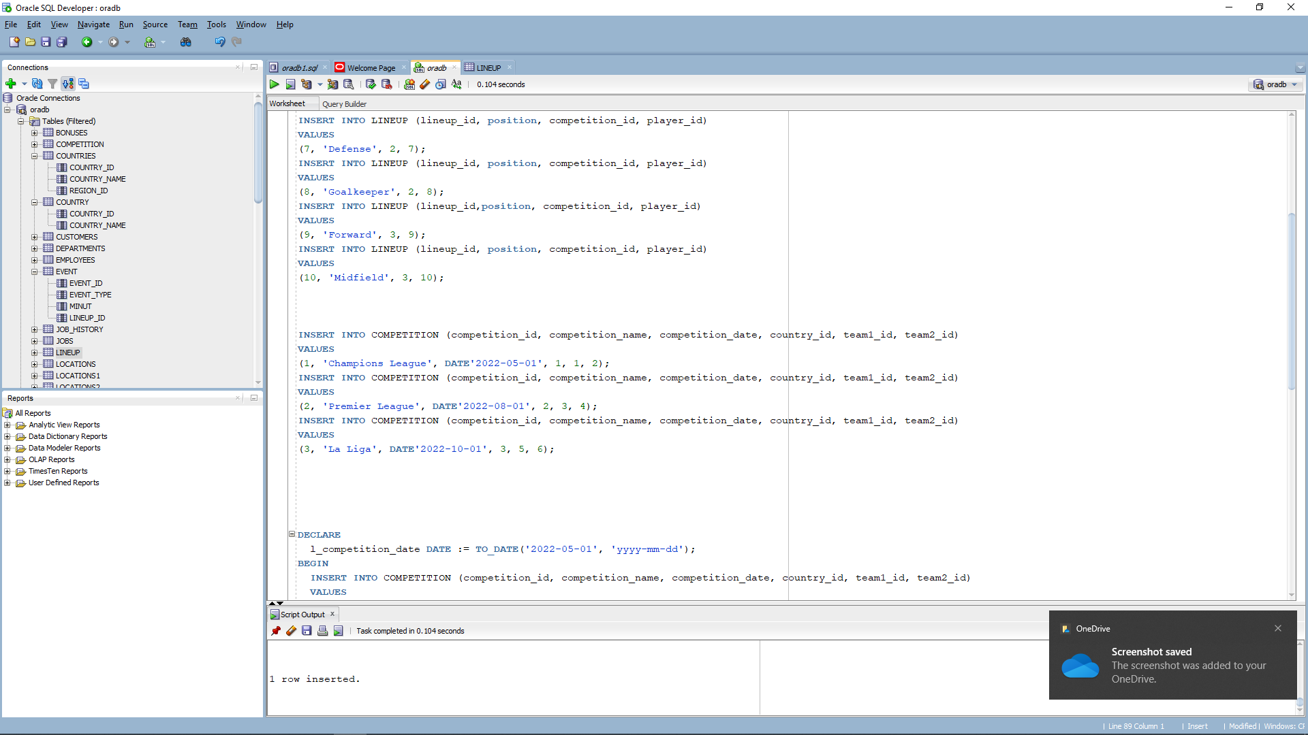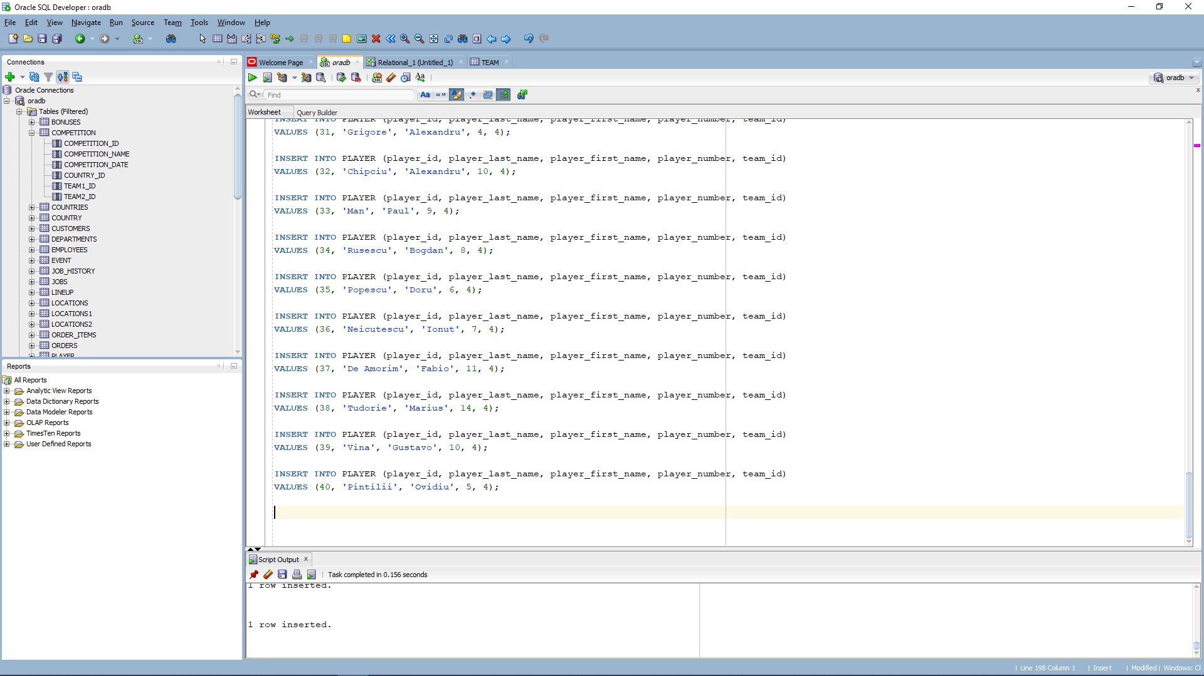



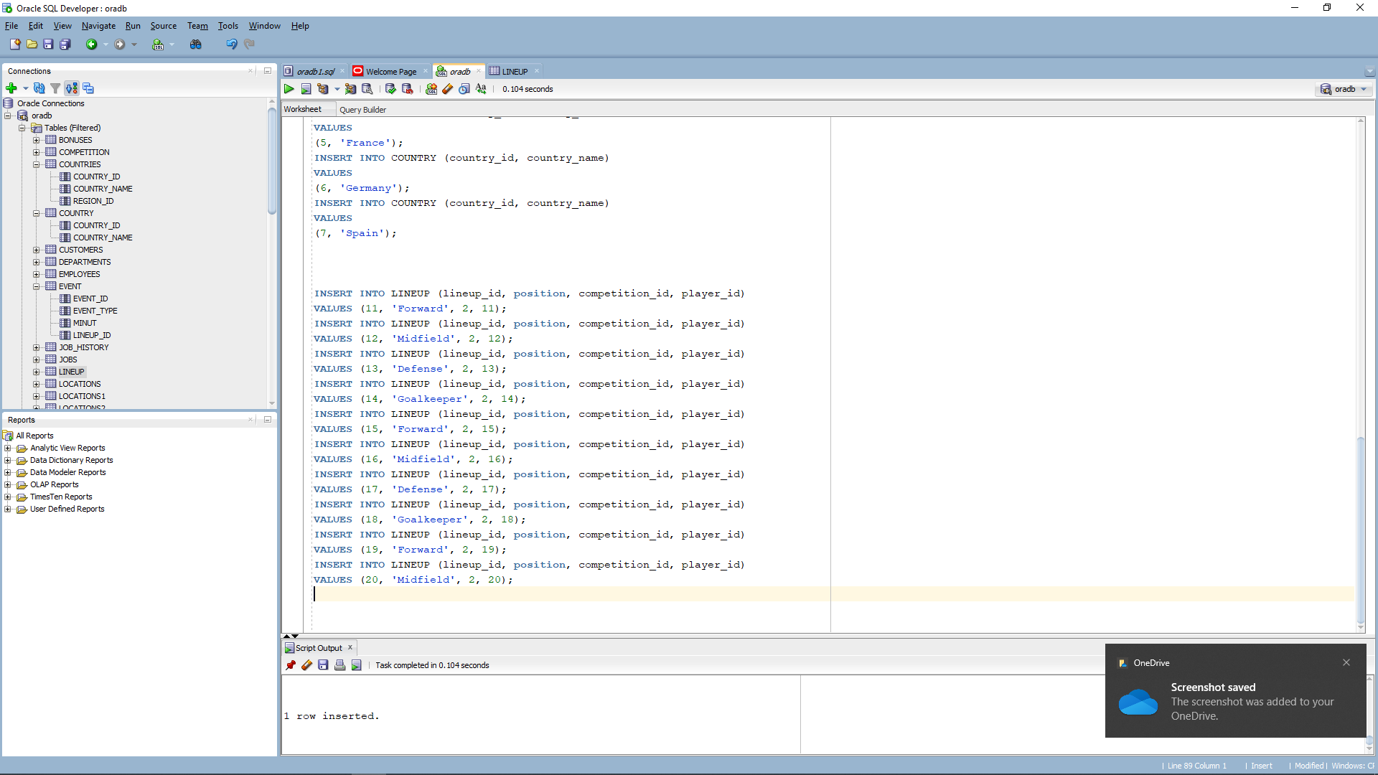

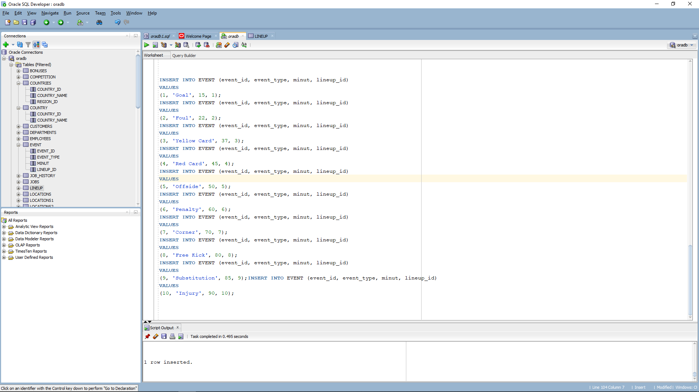

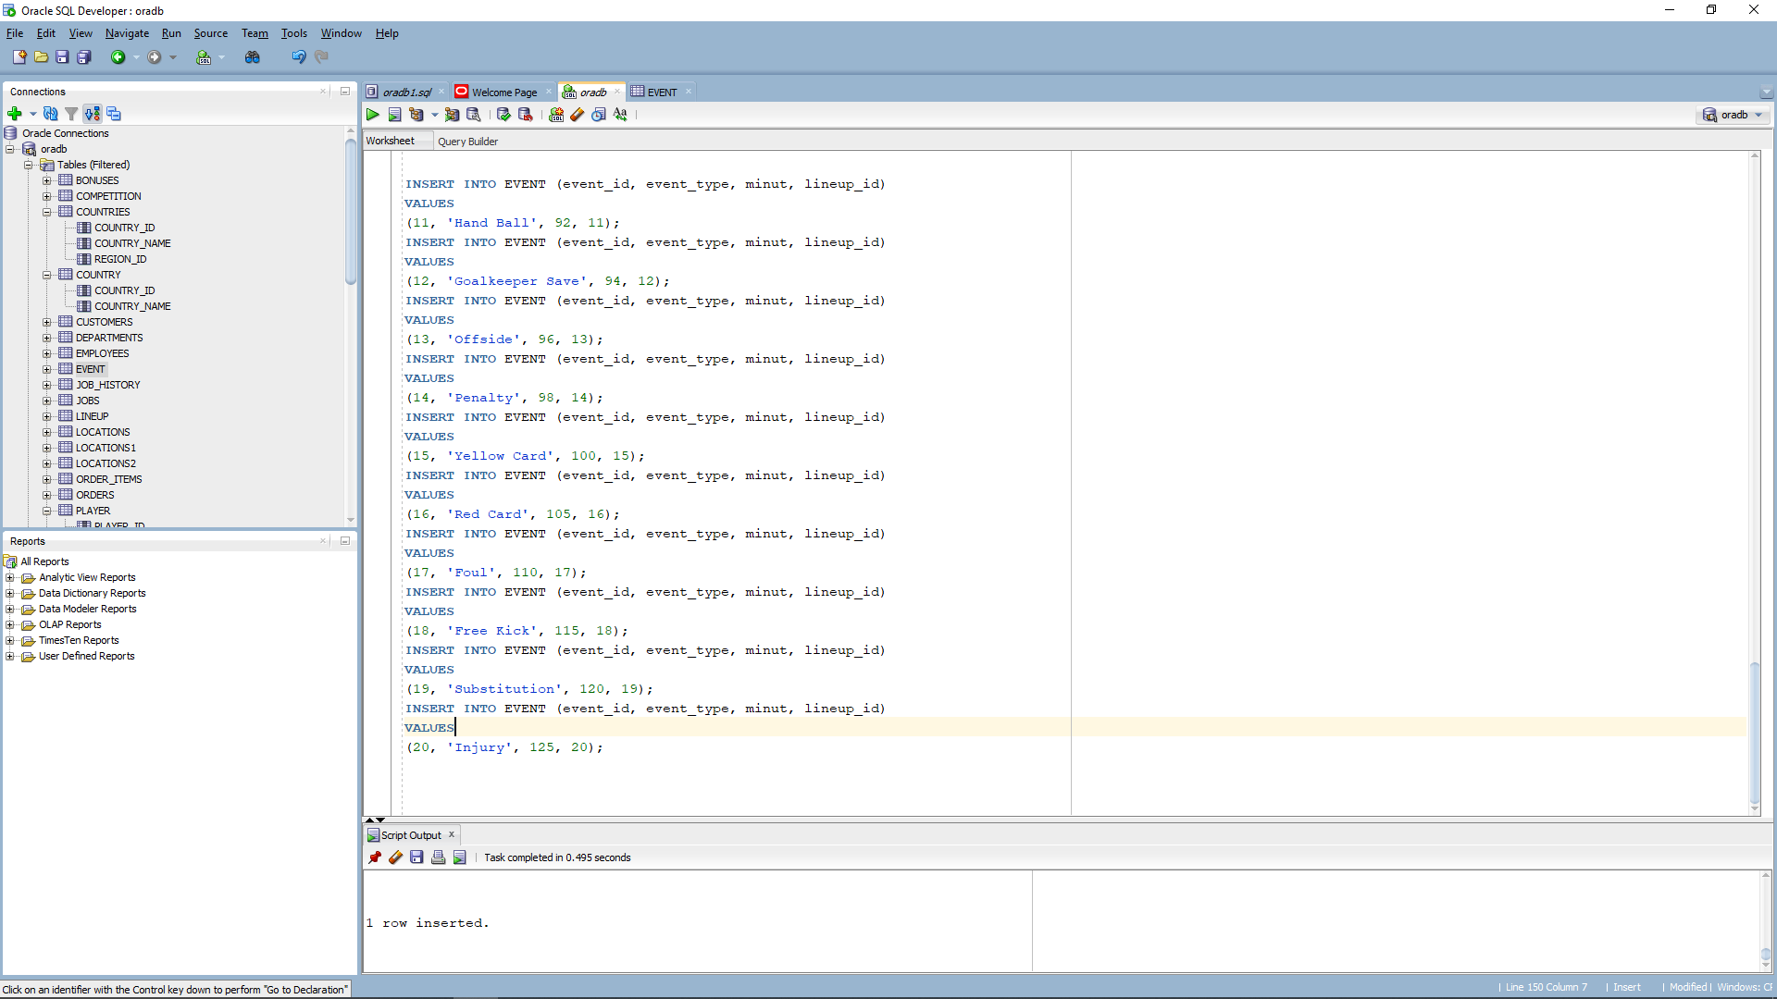

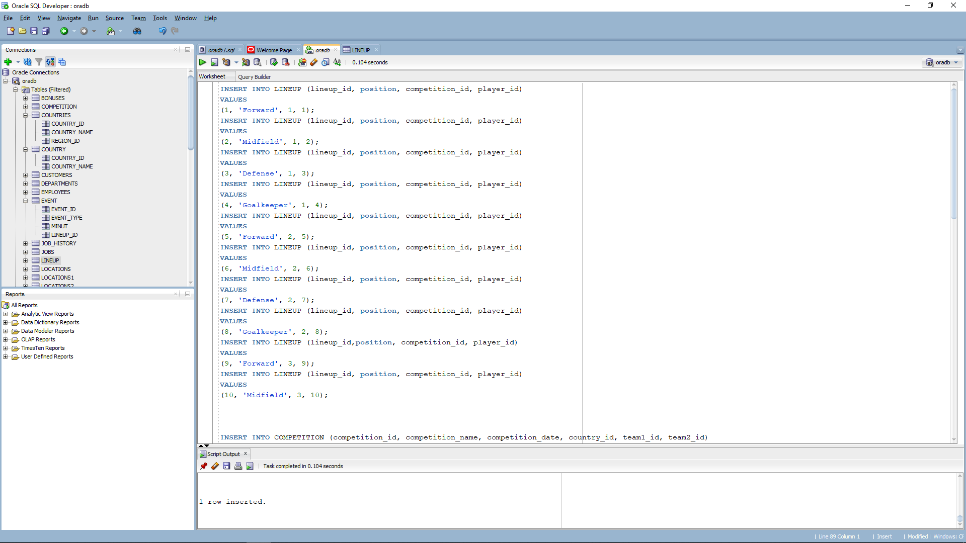

And the result :

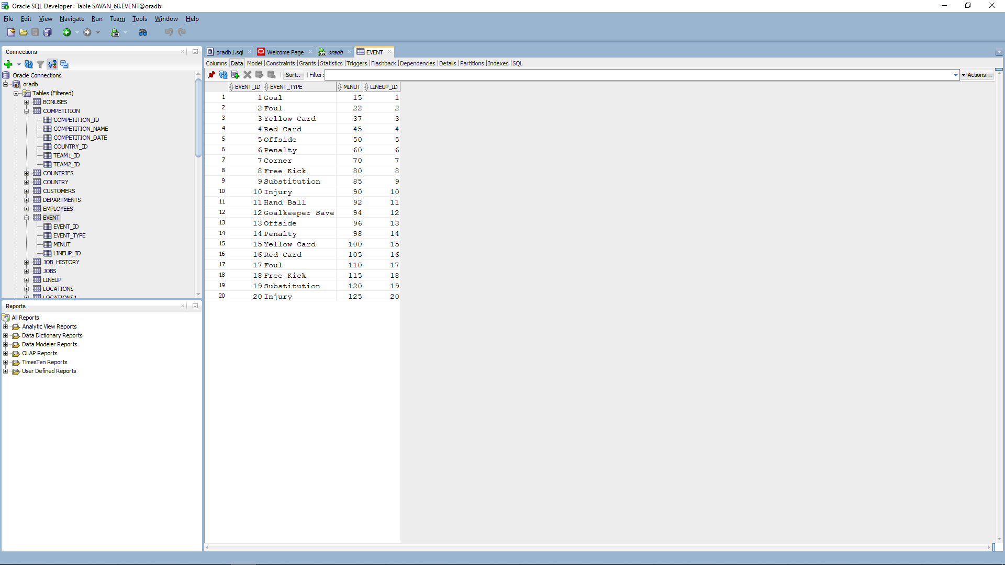

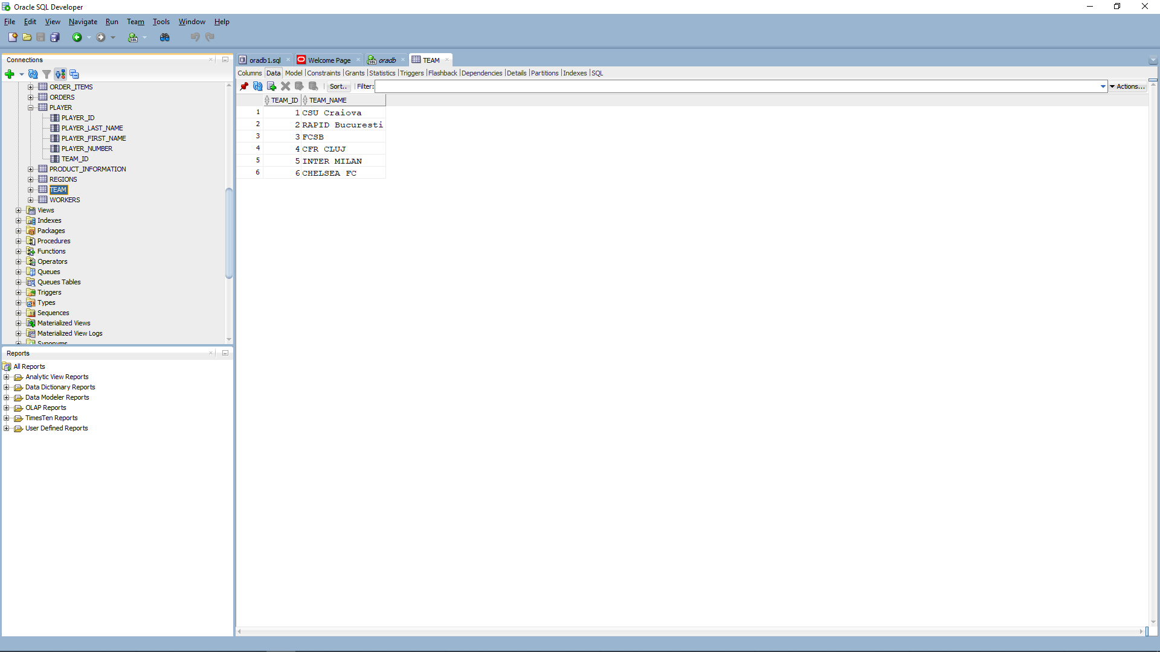

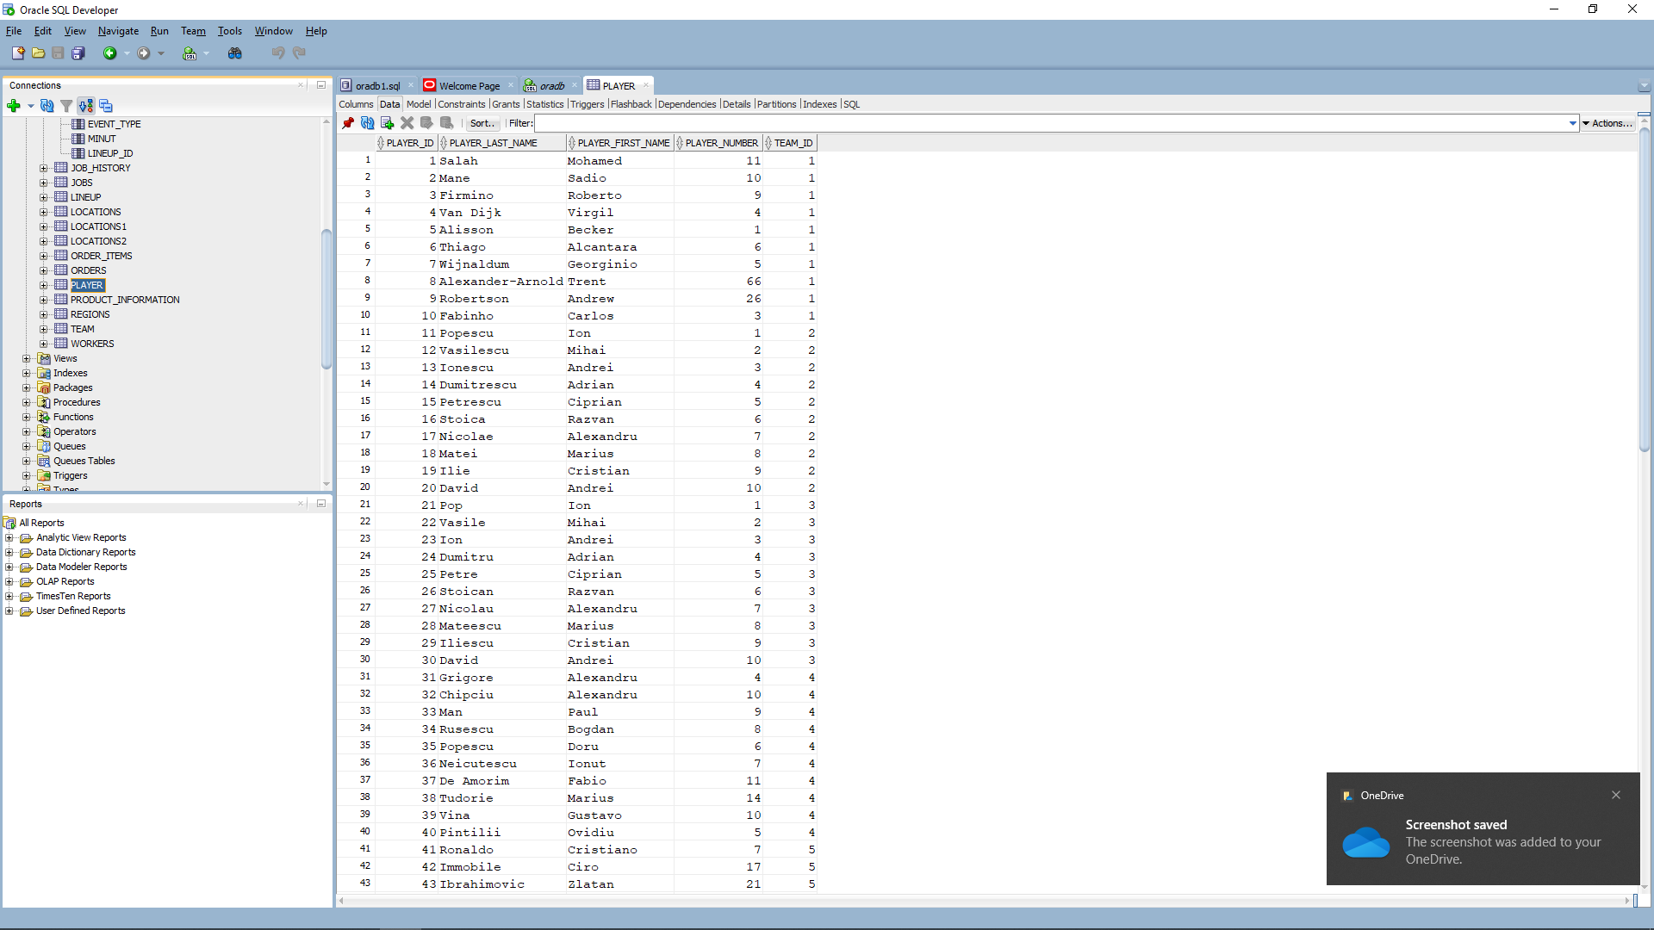

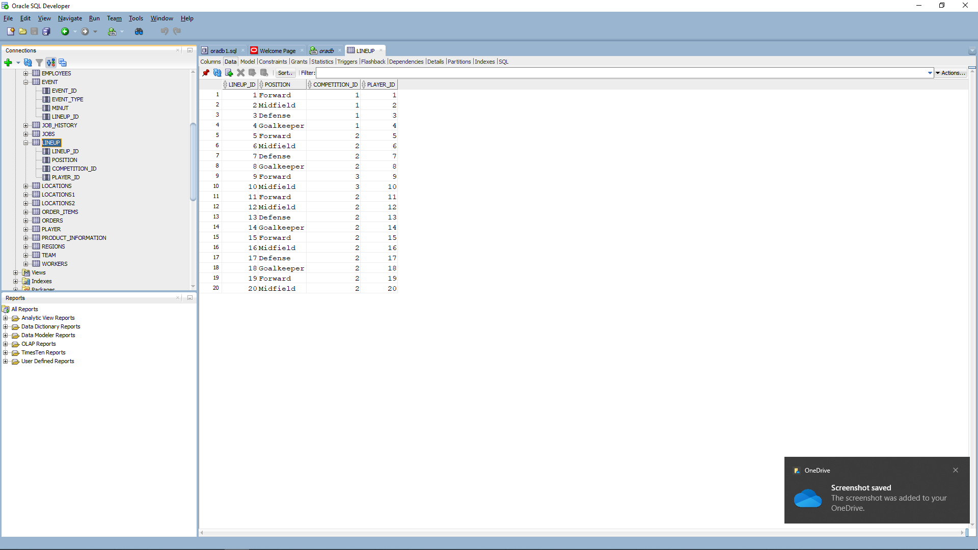

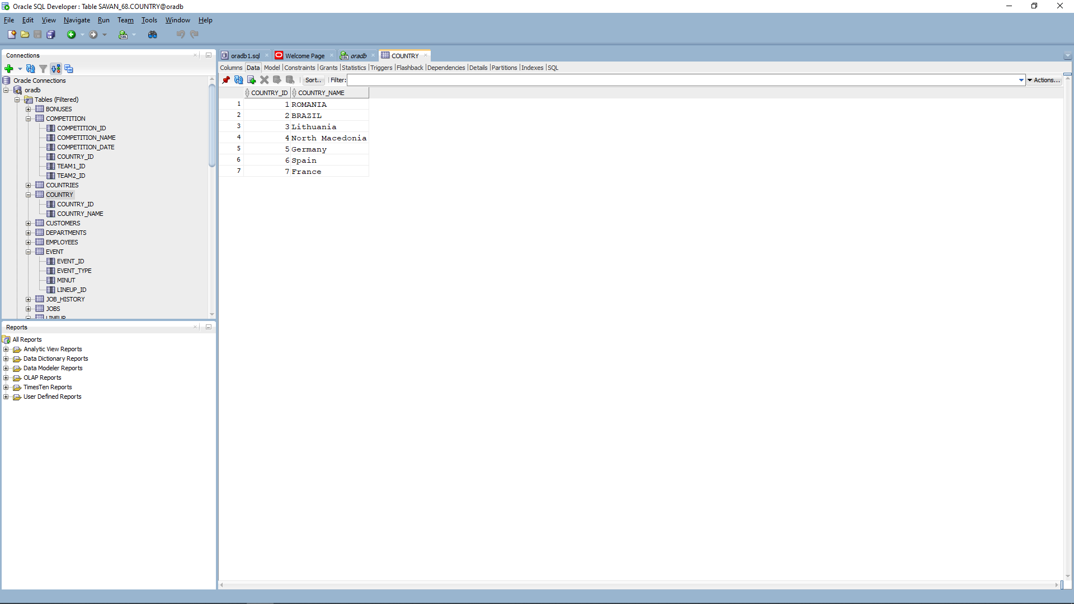

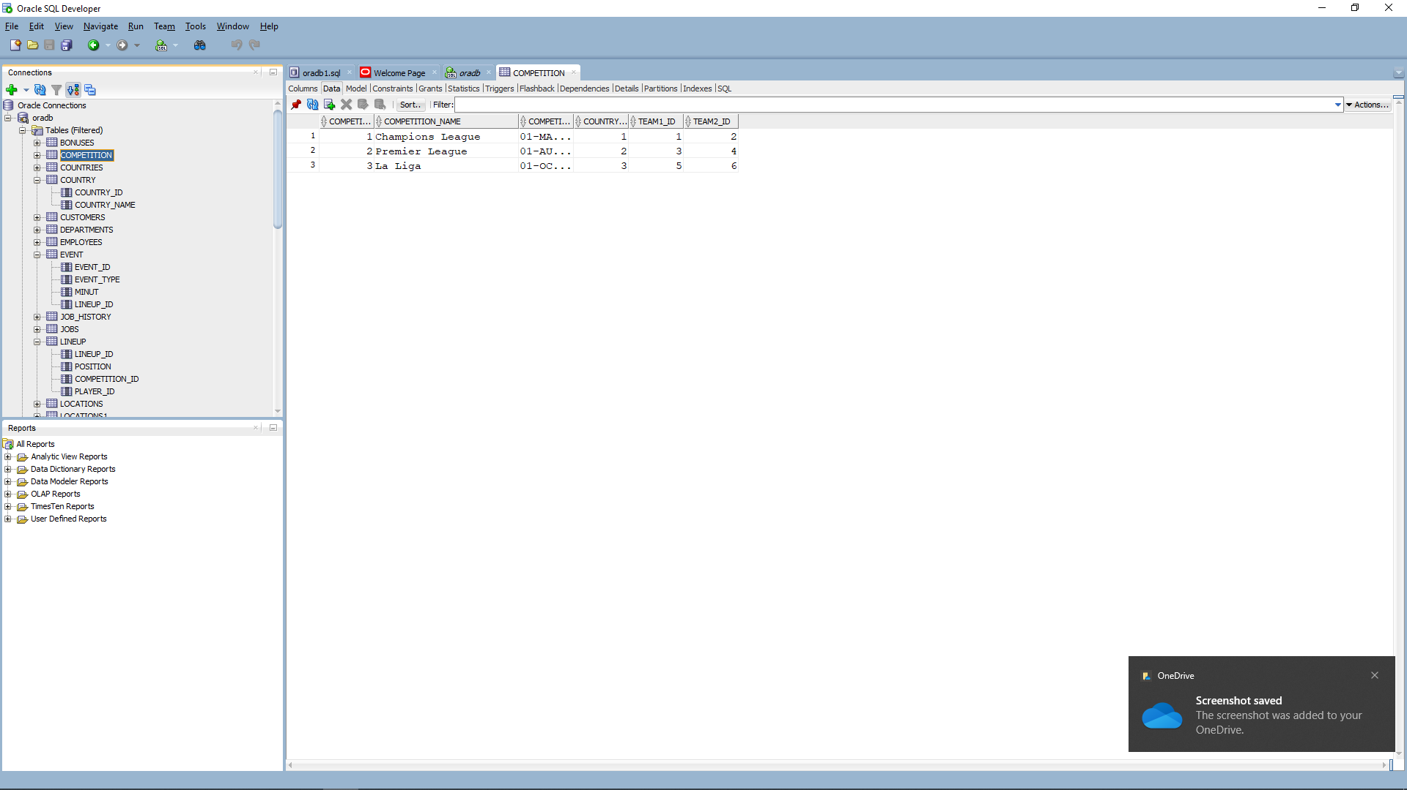

This are all my data that I inserted in my tables. Because at a point I made a mistake with inserting data I had to use a delete function to delete the data from player table between 41 and 50 :

So I wanted to check my database using exactly 15 select statements

1. Let`s see player`s last name, first name, player number, and the minute they played, but only for events where the minute is greater than 50

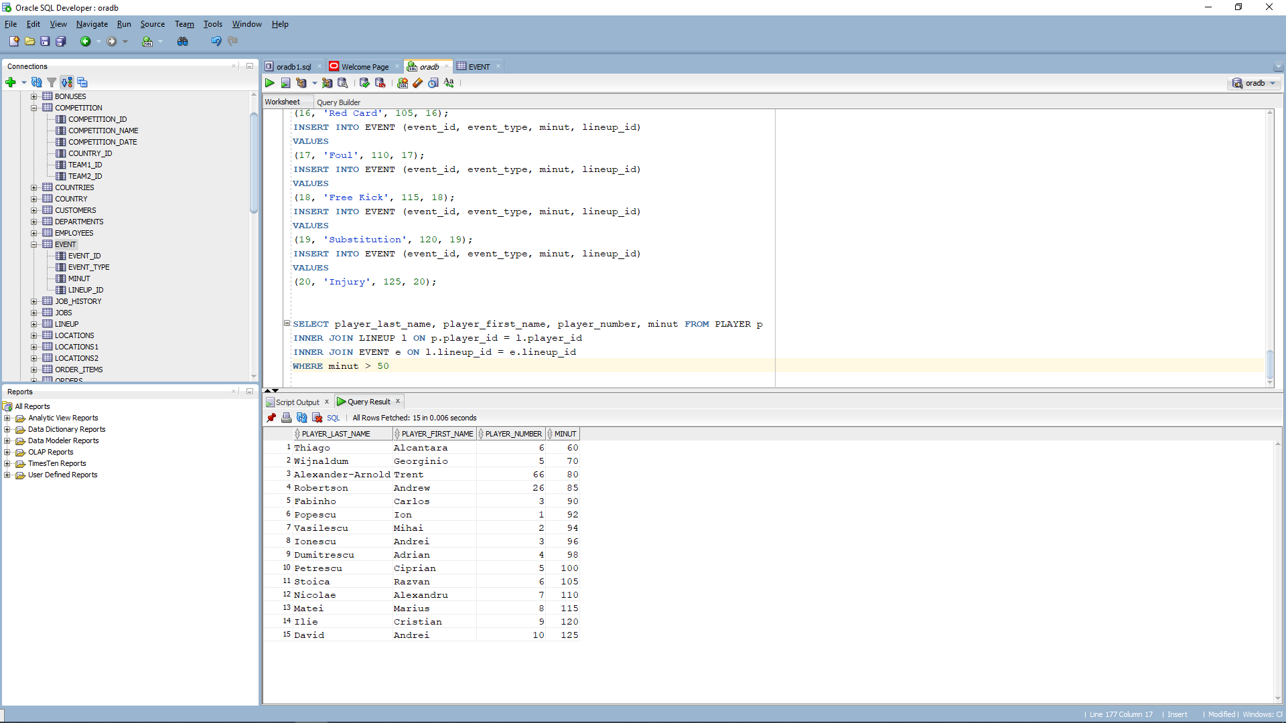

1. I wanted to use left outer join to select players` last name , first name and team name and return all the players in the player table, and the matching team name in the team table.

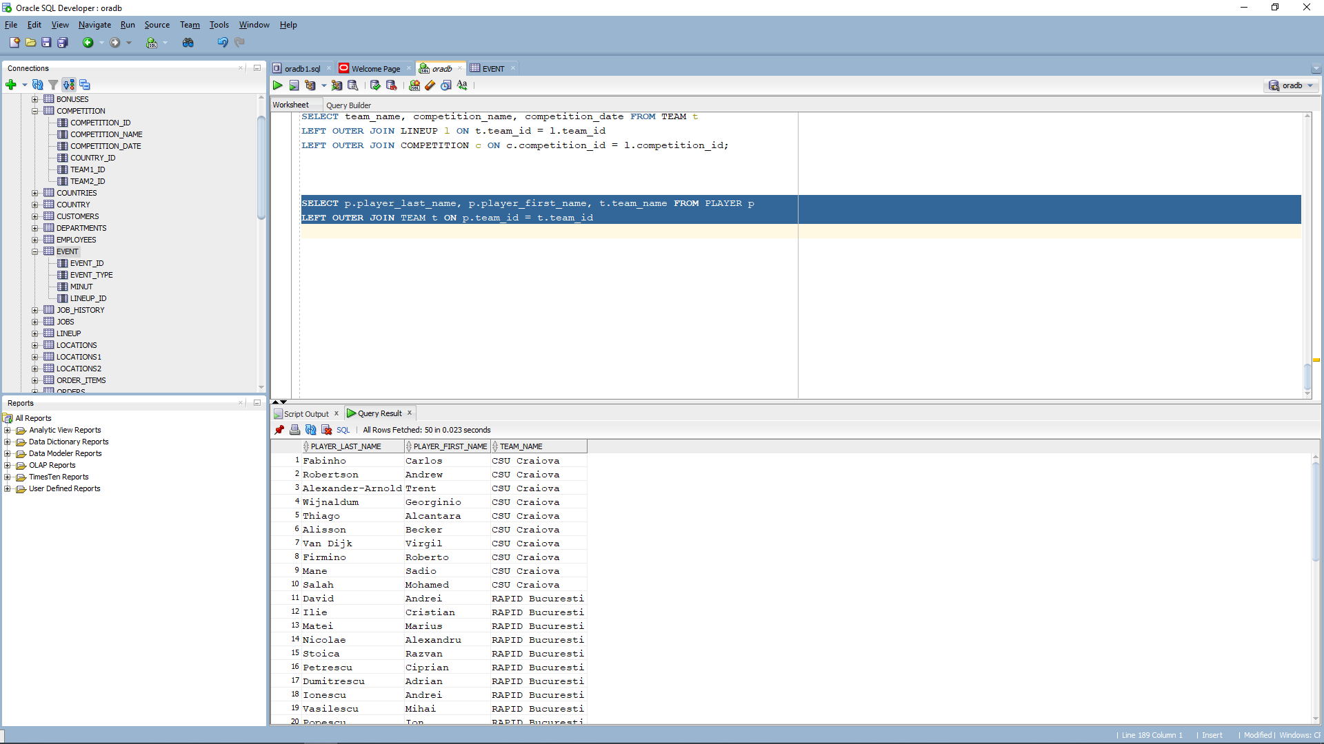

1. To continue, I wanted to select the team name and the total number of platers for each team then to group the result by team name and filter the teams that have more than 5 players.

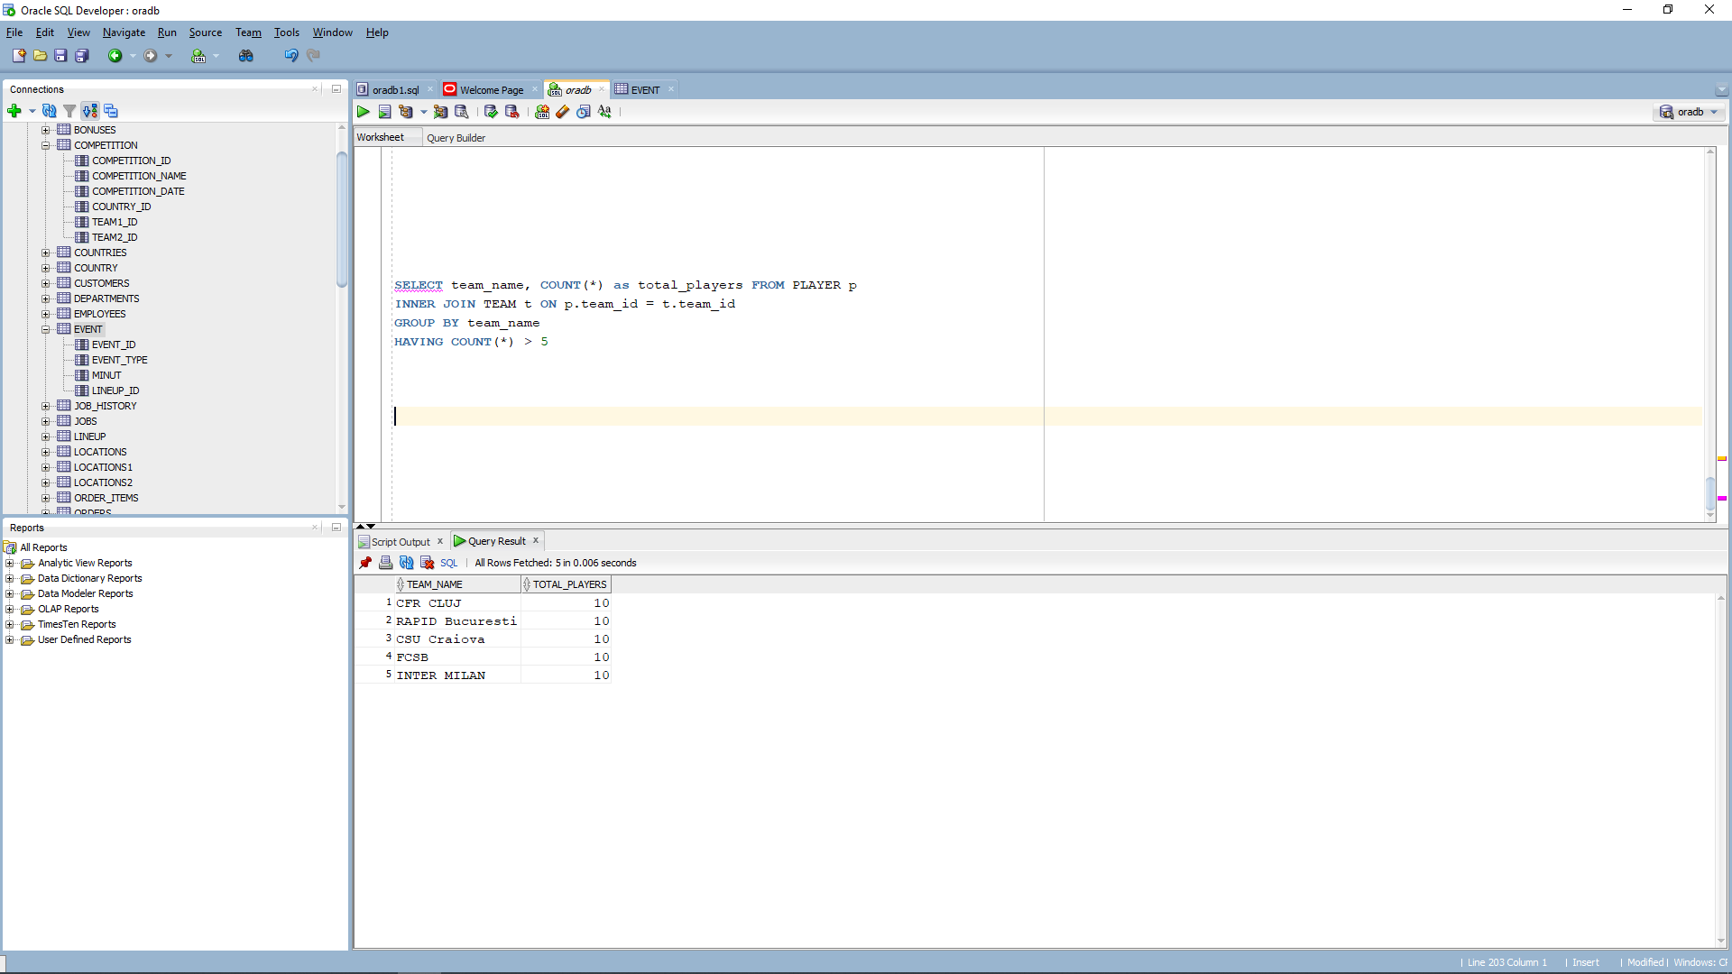

1. This select statement, in which I used extract function, is meant to select the competition name and the month from the competition date and returns an integer.

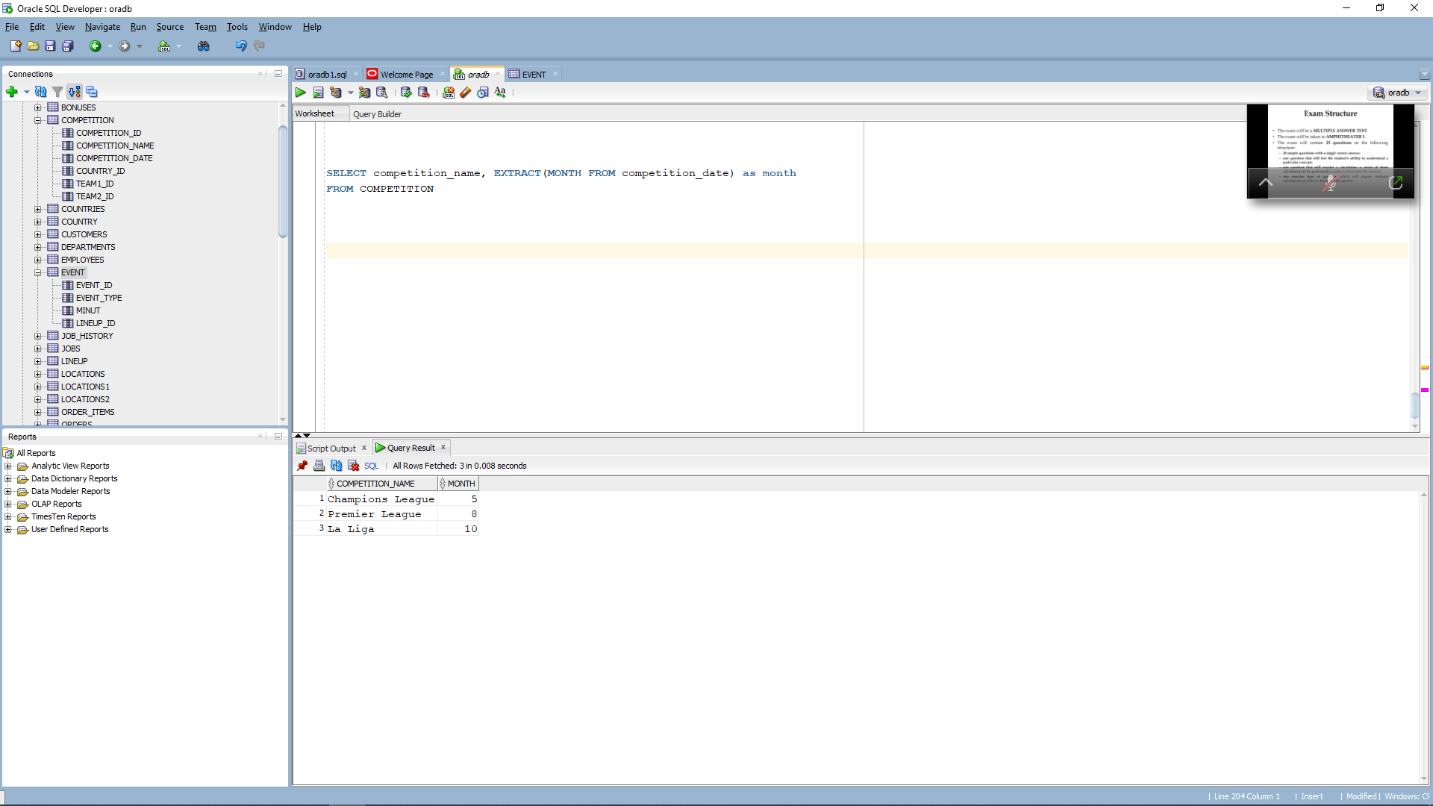

1. The following select statement, will select the player`s last name, first name, player number and the player position with the following conditions:

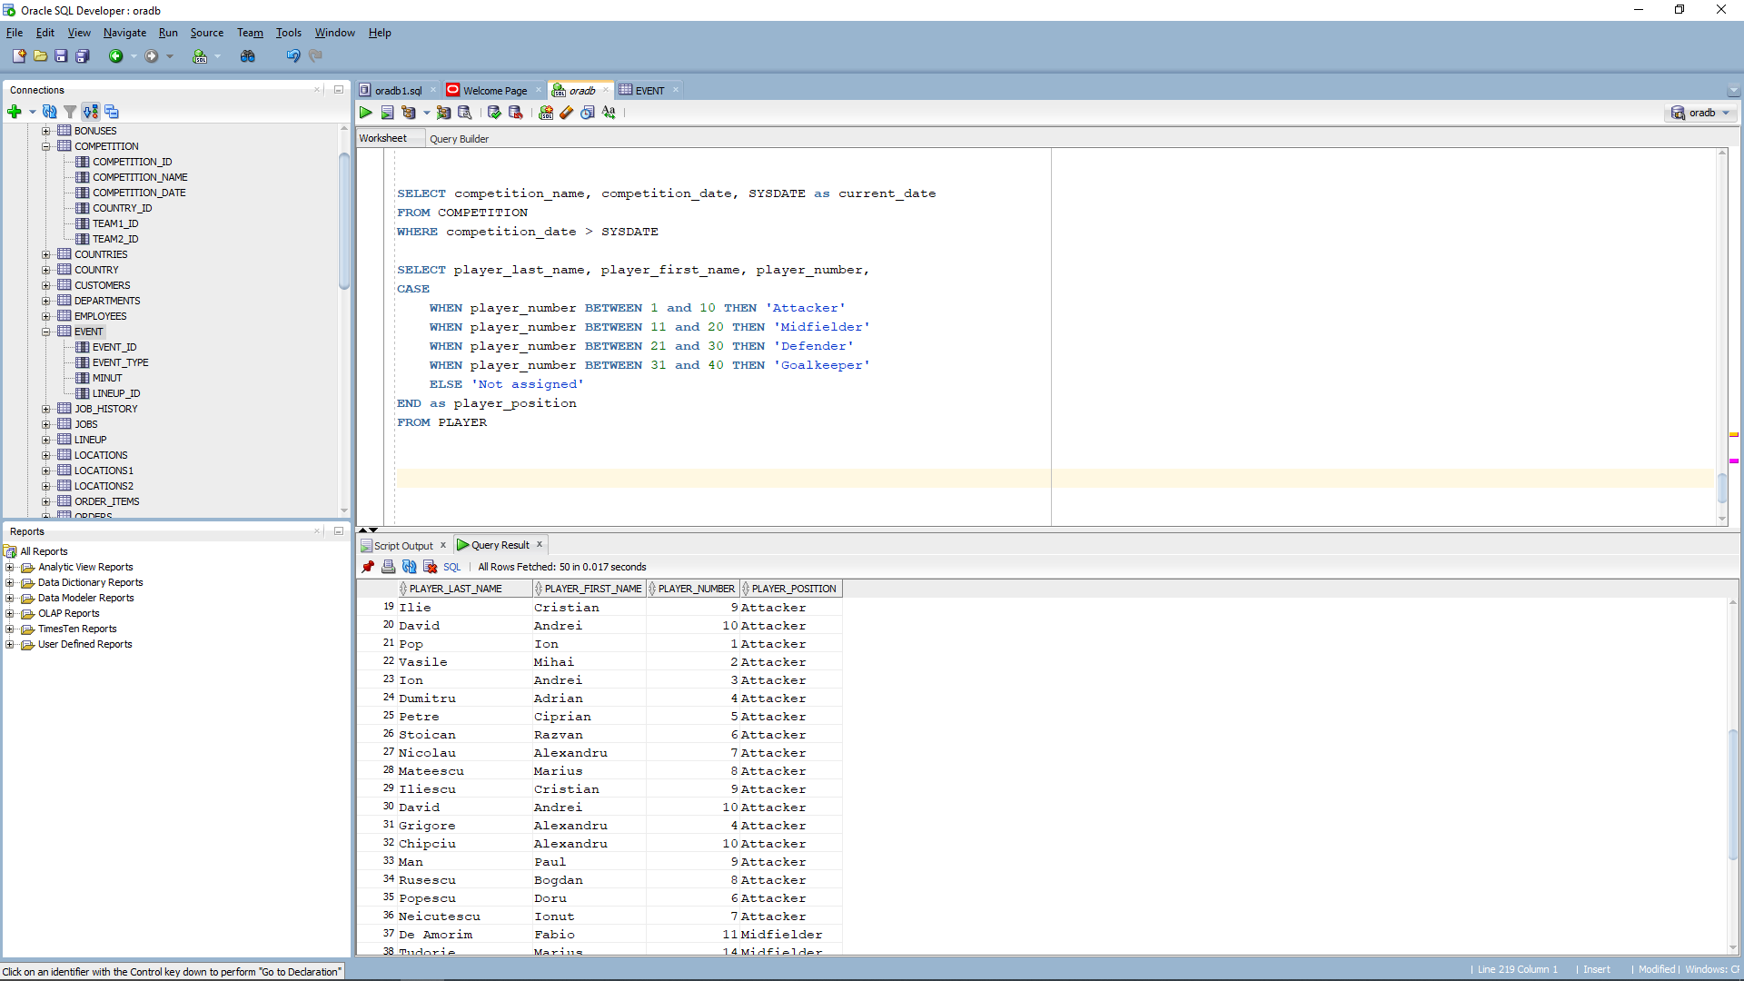

1. I wanted to select player`s last name and the first letter of the player`s first name, using substr function which is used exactly to extract a substring from a string.

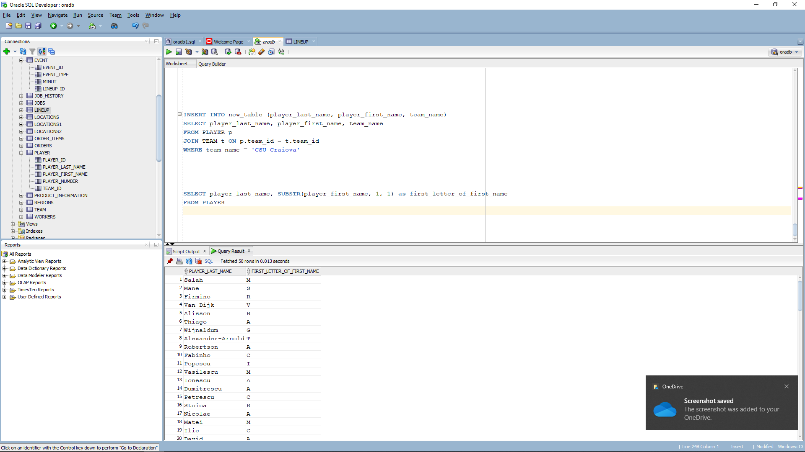

1. The following select statement, will select player`s last name, first name and team name for the players that belongs to the team CSU Craiova and Rapid Bucuresti and combine the results into a single result set, and using union will combine the both select statements for each team.

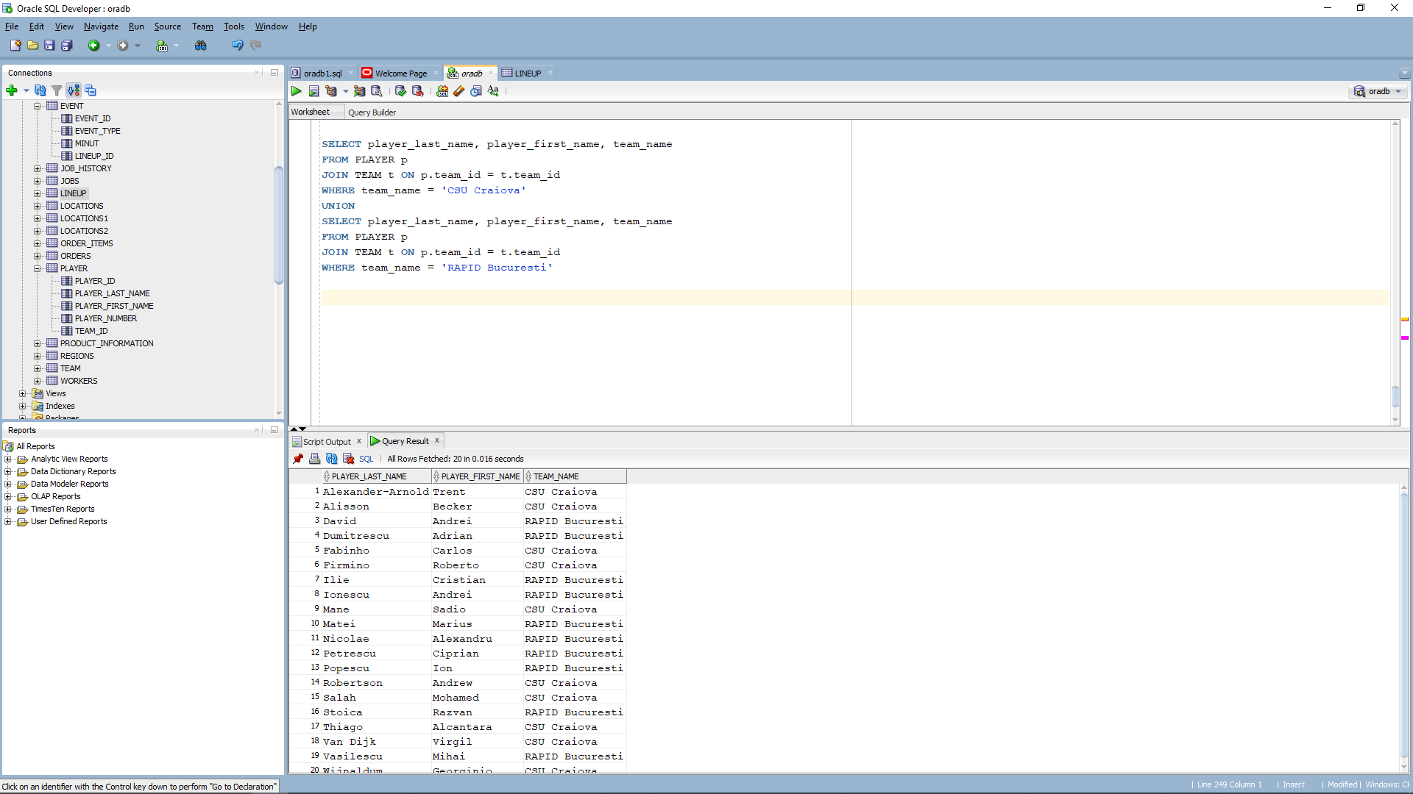

1. Using decode, we can select in this case, player`s last name, first name and team name only if the argument matches the table collumn

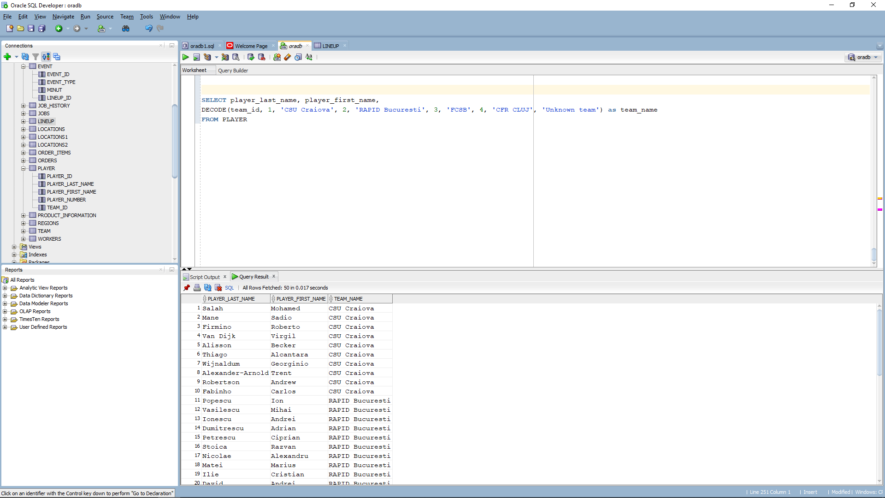

1. Using = , this select will display players that play for “CSU Craiova”.

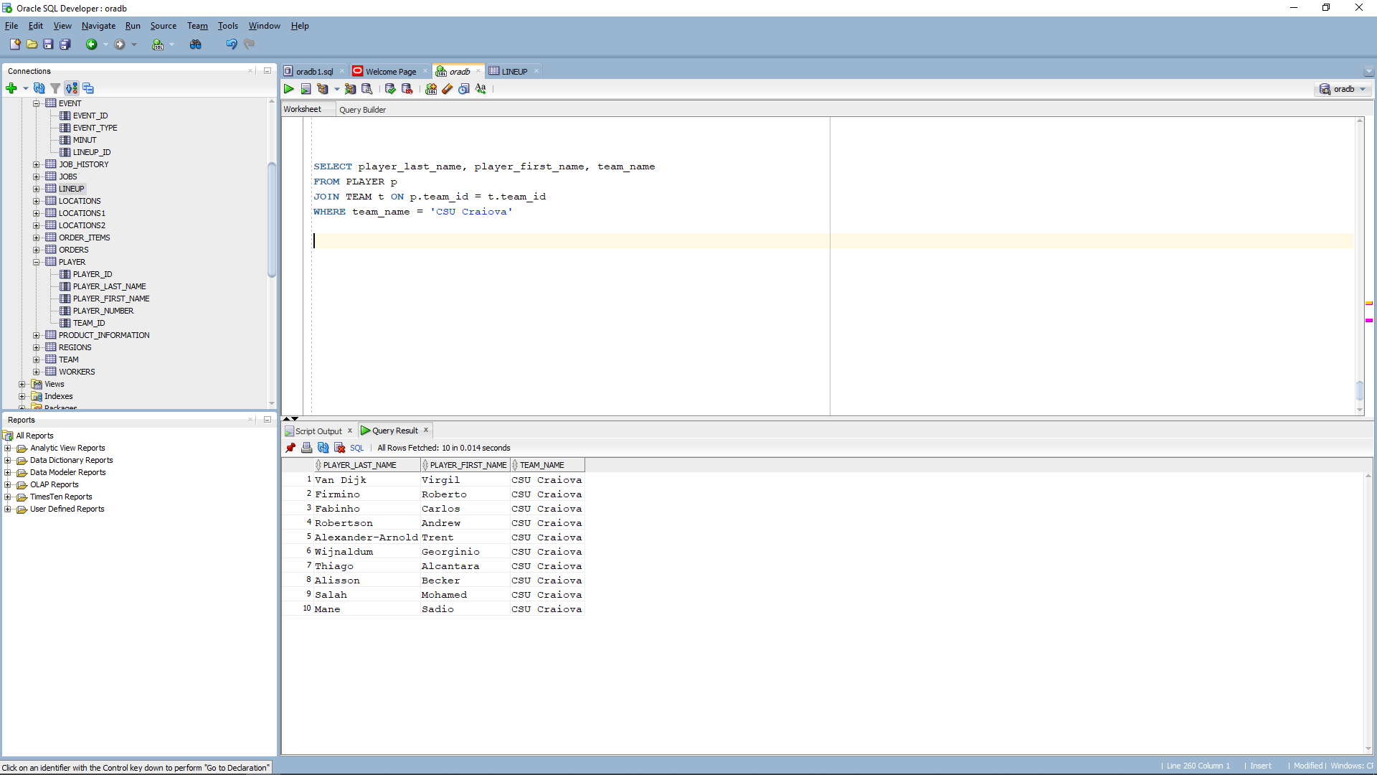

1. Using between function, it will display details about player which number matches our argument: between 10 and 15

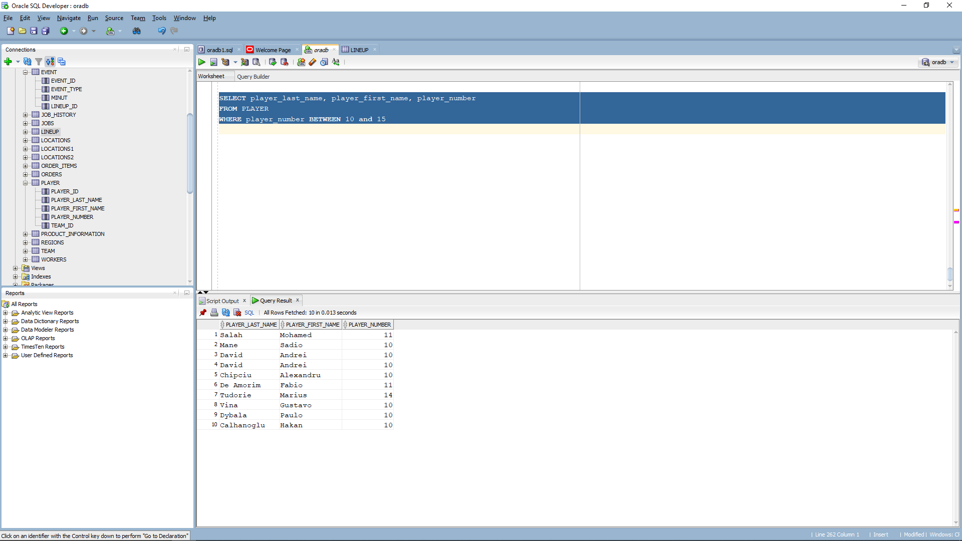

1. This statement selects the team name and competition name from the teams and competitions tables, and it uses a join clause to combine the data from both table the on clause of the join specifies that the team id should match either team 1 id or team 2 id from competition table, while where clause filters the result set by using the any operator . 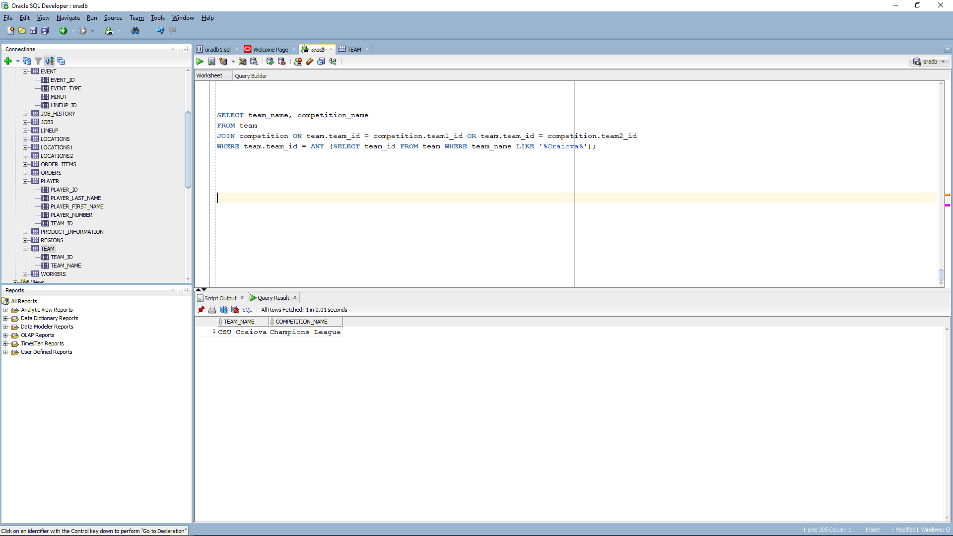
2. I used a statement that creates a view named player competition view which selects the player id player last name player first name player number team name competition name from player team and competition tables and it uses a join clause to combine the data from all 3 tables. Next, is selecting all the columns from the created view and filtering the results by the competition name named Champions League .

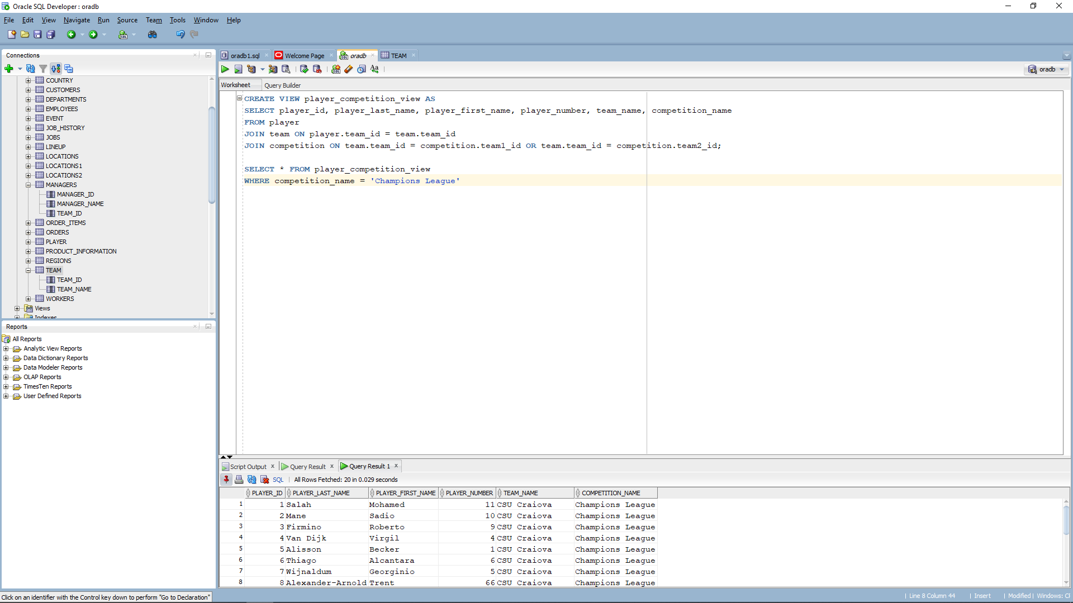

1. The following select statement selects player id player last name, first name and team id from the player table where team id equals to any team id that is retrieved from team table where team name contains letter a. the any operator compares a value to each value in a list.

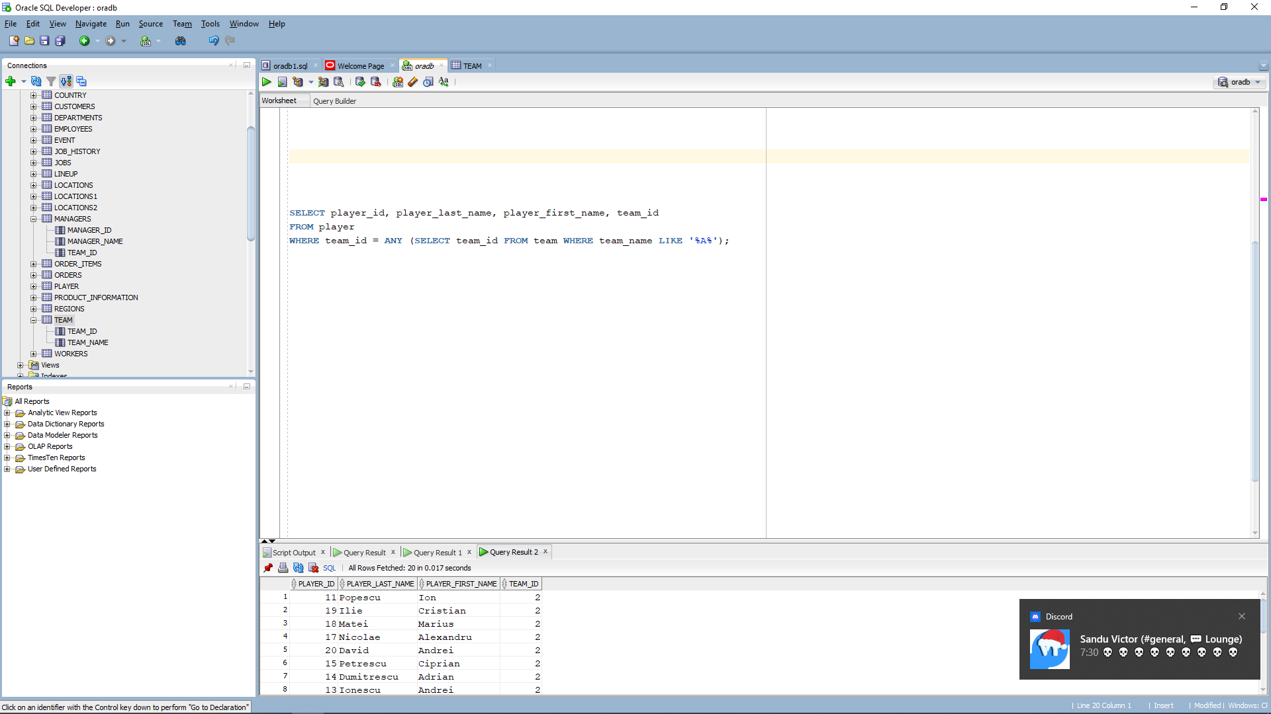

1. So I wanted to replace all null values of player number with 0 , and to do that I used nvl function. The nvl function replaces null values with a specified value in this case replaces any null values with 0.

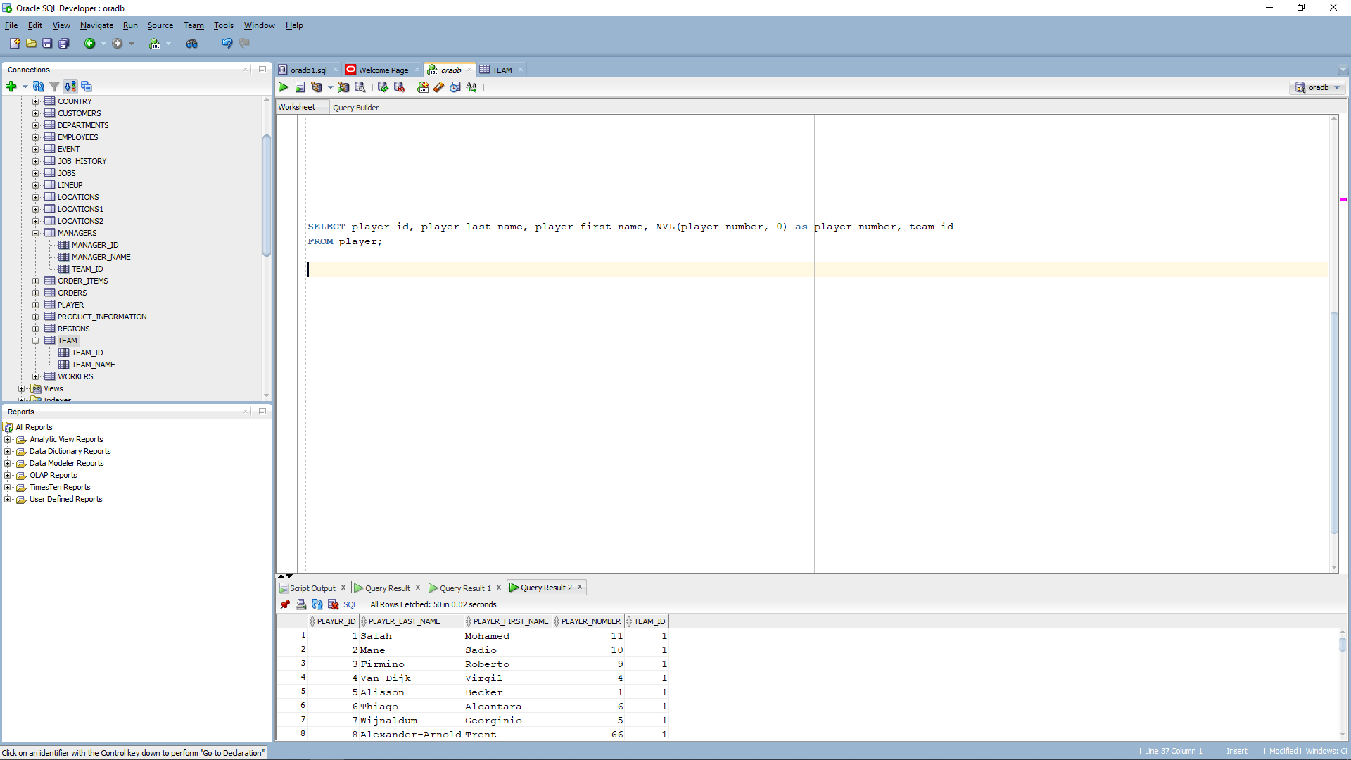

1. For the last select statement, I wanted to delete events that happened in the minute les then 25 .

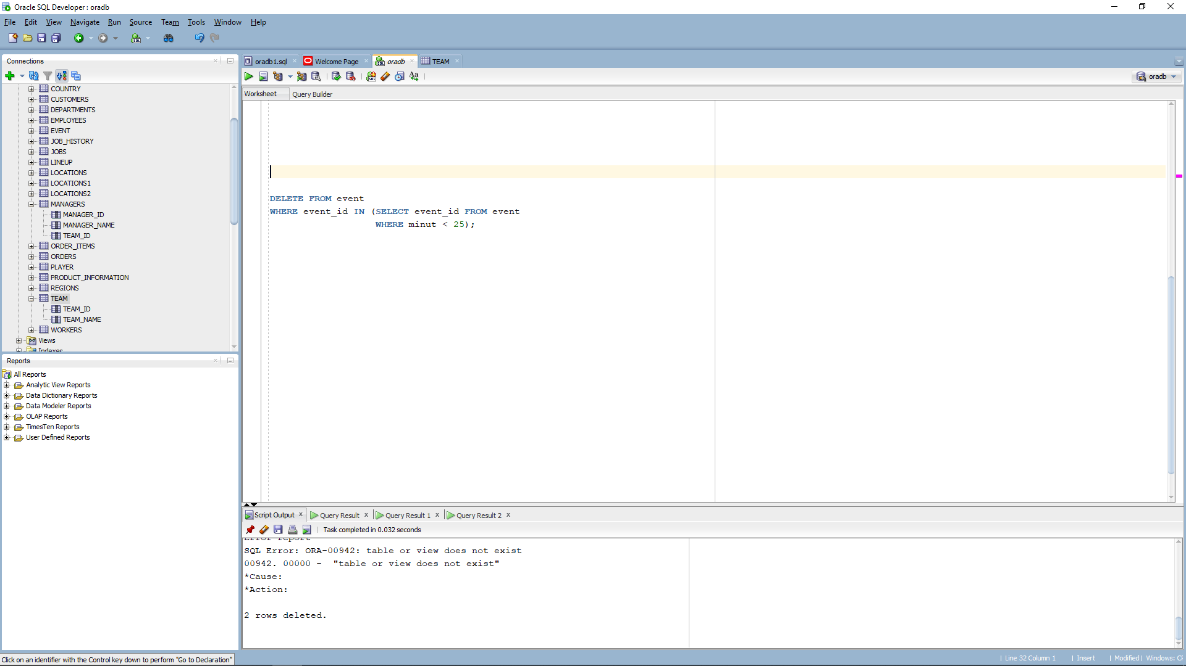

Me as a player for CSU Craiova.

